**Project Log Book**

**Group Members: JAWAD LODHI (61845)**

**SAAD ALI SIDDIQUI (61925)**

|  |  |
| --- | --- |
| **Entry Date** | **Work Done** |
| August 10th, 2020 | Discussed the basic plan to build the prototype for Café Mangement in class, noting down all constraints to be taken care of. Furthermore, we decided our next group meeting would be on August 15th, 2020, meeting place: Team Member’s House. |
| August 15th, 2020 | Meeting at Team Member’s House.: We discussed about the project objective. Using the Software Management Plan template printed from the web site, we stepped through each section and discussed what was required and what resources were available to us. We also discussed how this prototype should be flexible for other countries. There was constant reference to the "Café Management System" and other related articles. |
| September 1st, 2020 | Finished a rough draft prototype and set it up on the online account. |
| September 19th, 2020 | Team Member checked the document of the Software Project Management Plan, and he made some correction marking the corrections in red. |
| September 20th, 2020 | The mistakes were corrected on the web site, and email was sent to Team member to check the document for any more mistakes |
| September 22th, 2020 | The document was checked by Team Member and few more mistakes were found. These mistakes were corrected and put on the web. |
| September 24th, 2020 | Meeting at Team Member’s Place: We discussed the Management System in more detail and added more information to the Word document. |
| September 25th, 2020 | Team member checked the document of the Software Project Management Plan, and he made some corrections. |
| September 27th, 2020 | The mistakes were corrected on the web site, and email was sent to Team Member to check the document for any more mistakes. |
| September 29th, 2020 | Meeting at Team Member’s Place: We discussed parts 4 and 5 of the Software Project Management Plan in more detail and decided to update some information in the Word document. The different parts of the document were divided between the team for updates. |
| October 3th, 2020 | Finished updating the rough draft prototype and set it up on the online account. Sent all team members email with link to latest copy of the document. |
| October 4th, 2020 | Team member checked the document of the Software Project Management Plan. The mistakes were corrected on the web site. The latest version of the document is available online. |

***Last Updated on Novemeber 1st, 2020***

**Software Requirements Specification**

*For*

***Café Management System***

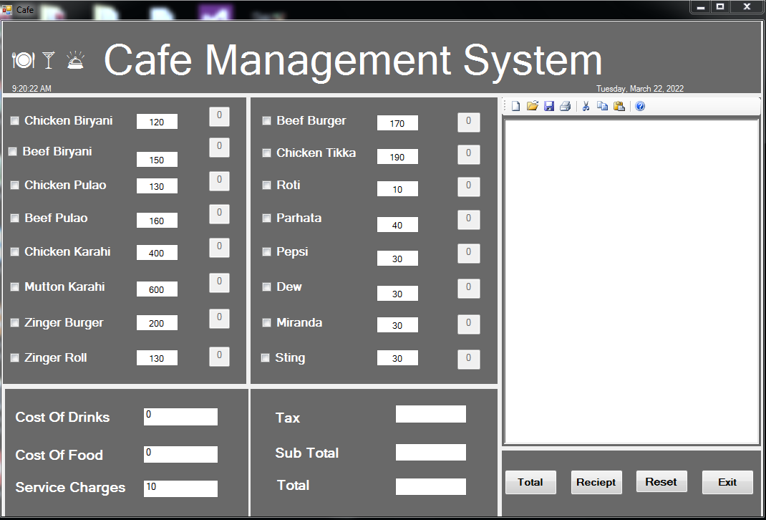

**JAWAD LODHI (61845)**

**SAAD ALI SIDDIQUI (61925)**

***MARCH 24, 2022***

|  |  |  |
| --- | --- | --- |
| Version | Changes Made | Date |
| 1.0 | [First Pass for Review](http://www.geocities.com/cs5391/SRS1.htm) | 10/24/2020 |
| 1.2 | [Second Pass for Review](http://www.geocities.com/cs5391/SRS2.htm) | 11/07/2020 |
| 1.3 | [Third Pass for Review](http://www.geocities.com/cs5391/SRS3.htm) | 11/28/2020 |
| 1.4 | Café Management Review Version | 12/04/2020 |
|  | | |

**Table of Contents**

1. Introduction

2. The General Description

3. Specific Requirements

4. Supporting Information

**1. Introduction**

**1.1 Purpose**

The main Purpose is to develop this management system is to give more benefits to café owners, so they can easily select items from menu and generate bill for the customers. Also this management system can be use in many restaurants as an efficient system.

**1.2  Scope In**

The scope of Cafe management is very vast. It includes everything regarding the efficient

Functioning of the food departments, securing the greatest benefit to the greatest number through

An adoption of practical measures. It interprets and clarifies the functions and the activities of

Restaurants.

* 1. **Scope Out**

The following features will not be the part of this Project:

1. Cloud Back-up
2. Inventory Management.

**1.4 References**

* ["Modules for café and restaurants"](http://www.capita-sims.co.uk/our-products/primary-schools-and-academies). Capita Group. Retrieved 14 November 2014. Is one of the application which provide the platform for café’s but in this project is only for cafe in that way our project is different from that

Appendix A: Glossary

In this digital era, it is vital and requisite that every restaurant should have modern and reliable café management system, so that they can make better and faster decisions to maintain the growth of the alliance. But sometimes due to unawareness of the important features of cafe software, cafes might end up using software which fails to fulfill their needs. That’s why we decided to create cafe management software.

**2. The General Description**

This section describes the general factors that affect the product and its requirements. This section consists of five subsections that follow. This section does not state specific requirements. Each of the subsections makes those requirements easier to understand; it does not specify design or express specific requirements. Such detail is provided in section 3.

**2.1 Product Perspective**

In this project we have many facilities such as Login in, Menu, Generate Bills, Slip Print information, Reset etc. These function helps you to manage record, you can use any facilities as you require. You can easily Add, Update, Delete, Search record as well. These are the common function of the project.

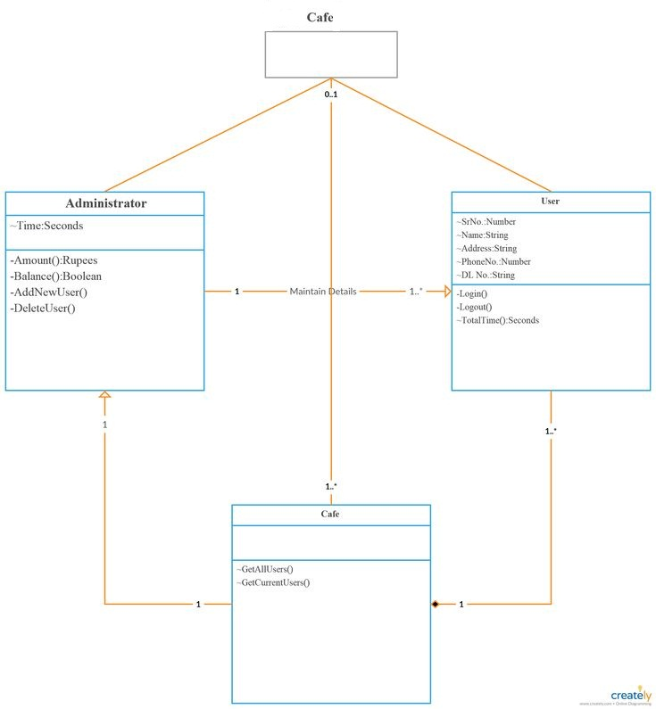Figure 2.1 Architecture Diagram of the Café Management System

**Functions of System Components:**

Database:

•       Stores data

•       Creates Bill

•       Provides access to data

•       Updates information

  •       Produces report / bill

**External Interfaces:**

## User Interfaces

We will design that type of interface which will be easy in used and understandable for all type of user and layout will be simple and attractive for users. We will design ERD diagram of the database then normalized the following database and complete the normalization process and generate a database without issues.

## Hardware Interfaces:

Development PC: PC with MS Windows 10

## Software Interfaces

SQL For our database Visual Studio is the Compiler.

## Communications Interfaces

In our project the communication interfaces are that the shall have complete records of the customer. Admin shall access all the data related. User shall print and save all the Bills as a backup. And this is the best functions to ease our users

## Product Functions:

In our project the product function is the Menu with Checkboxes, Bill Generation, and the main function is the Updating records or Bill Prints.

## Operating Environment

We use the hardware according to the requirements is the PC with MS Windows 10.The software we are using is the SQL, Visual Studio.

## User Documentation

Thus, applications, software development, and their necessary peripherals and experience carry increasing financial costs for organizations. The important role in project is admin who knows how to manage every information schedule and also update, delete, add and search every information or records of the customer.

Figure 2.2  **Use Case** Diagram of Café Management System

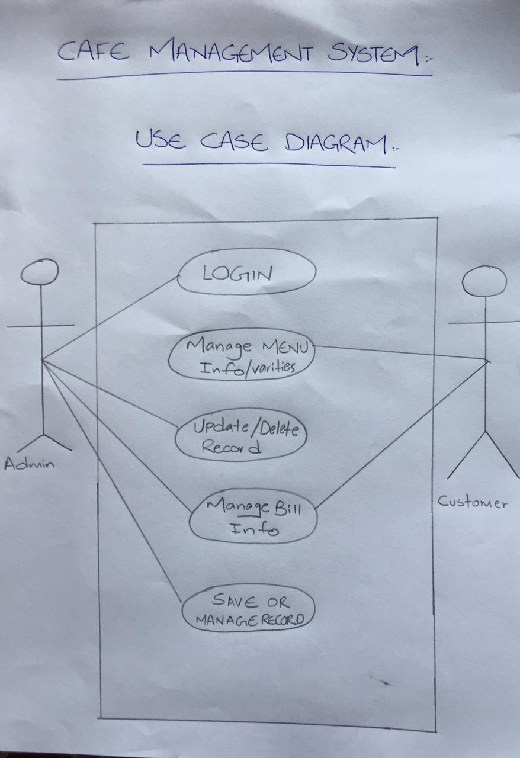

**2.2.2 Function Descriptions (Functional Requirement Listings)**

**2.2.2.1 Log in Function**

***Description:*** This function ensures that only authorized users gain access to the café management dashboard. The user must type a valid username and password to gain access.

**2.2.2 Module 1: Creating bill and generating receipts**

***Description:*** This function allows the user to Make a slip or generate bill for the customers.

User will generate a slip for the customer and will give that bill after dine in.

**2.2.3 Module 2: Can save all the records / bills as a backup**

***Description:*** This function will update all the information of the customer’s order and user can also print / save the bill or slip as a backup.

**2.2.4 Module 3: User Friendly interface / tick down menu**

***Description:*** This function allows the user to deal with a very easy interface in which he can select the items which customer have ordered and can generate slip of that order.

**2.2.5 Module 4:**

***Description:*** This function

**2.2.6 Module 5:**

***Description:*** This function

## 2.3 User Classes and Characteristics

In first step we will design ERD diagram of the database then normalized the following database and complete the normalization process and generate a database without issues. We will design that type of interface which will be easy in used and understandable for all type of user and layout will be simple and attractive for users.

## 2.4 Design and Implementation Constraints

The Design Phase of the project started in early September, and we will continue working on the following aspects. We will design a user interface that is easy to use and can display all the desired products and items which will be helpful for user.

## 2.5 Assumptions and Dependencies

In our project we need to put admin change information as well, we will try to do that as well for make our management system more efficient. The best way to improve user record performance and close achievement gaps is to establish rigorous content standards and a core curriculum for all café’s or restaurants preferably on a daily basis.

**OOAD REPORT DIAGRAMS**

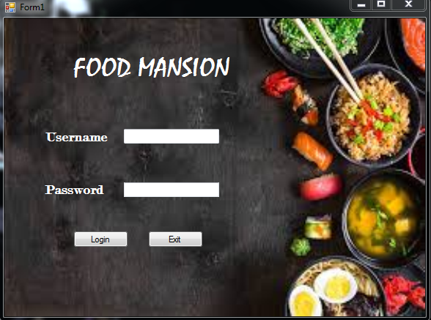



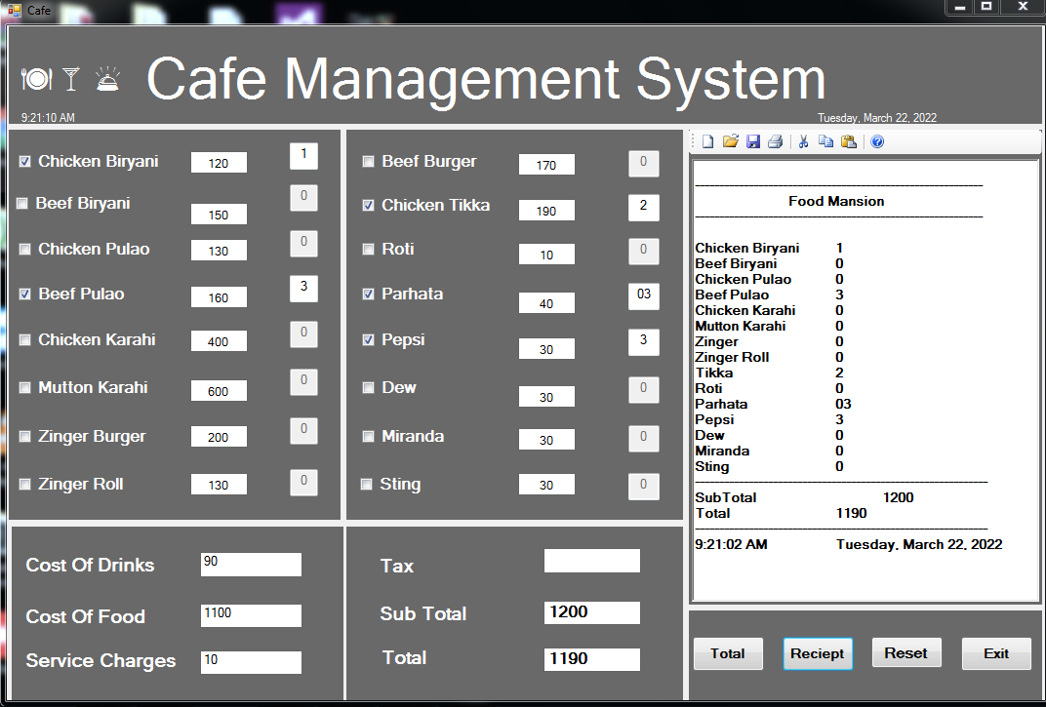

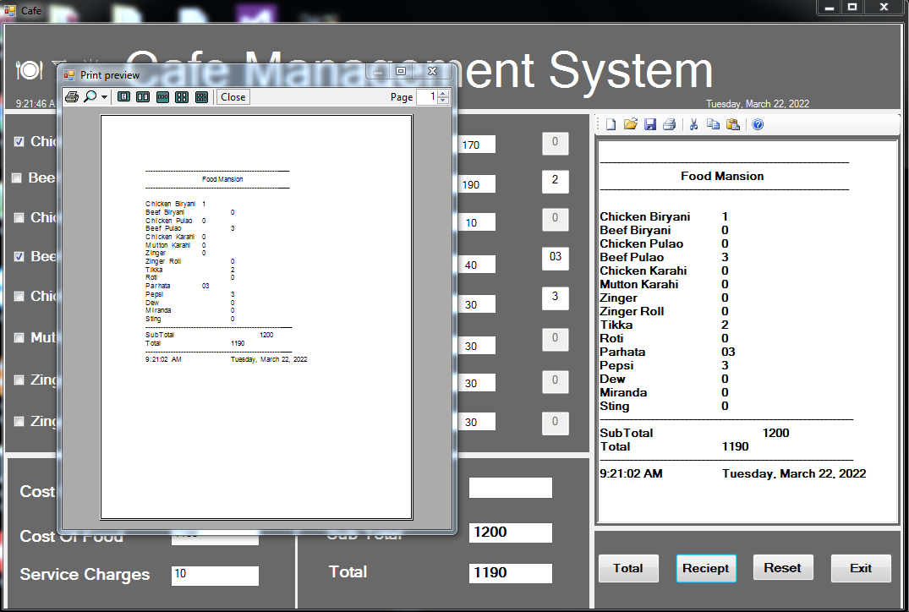

**3. Specific Requirements**

This section of the SRS contains design requirements for the Café Management System.

**3.1 Functional Requirements**

**3.1.1 Log In Function**

***Description:*** This function ensures that only authorized users gain access to the café management dashboard. The user must type a valid username and password to gain access.

1. ***Specification:***

|  |  |
| --- | --- |
| Description | Allows access to Café management system |
| Inputs | Username, password |
| Source | 1. User inputs username and password 2. Press Login Button |
| Alternate case | - |
| Outputs | Successful login; unsuccessful login |
| Destination | Cafe Management Menu |
| Precondition | Authorized User |
| Post Condition | No change to User’s Database |
| Side Effects | - |

1. ***Detailed Use case Diagram for Login: optional***
2. ***Use case Realization for Login: optional***
3. ***Flow of Event or Data Flow Diagram for Login: optional***

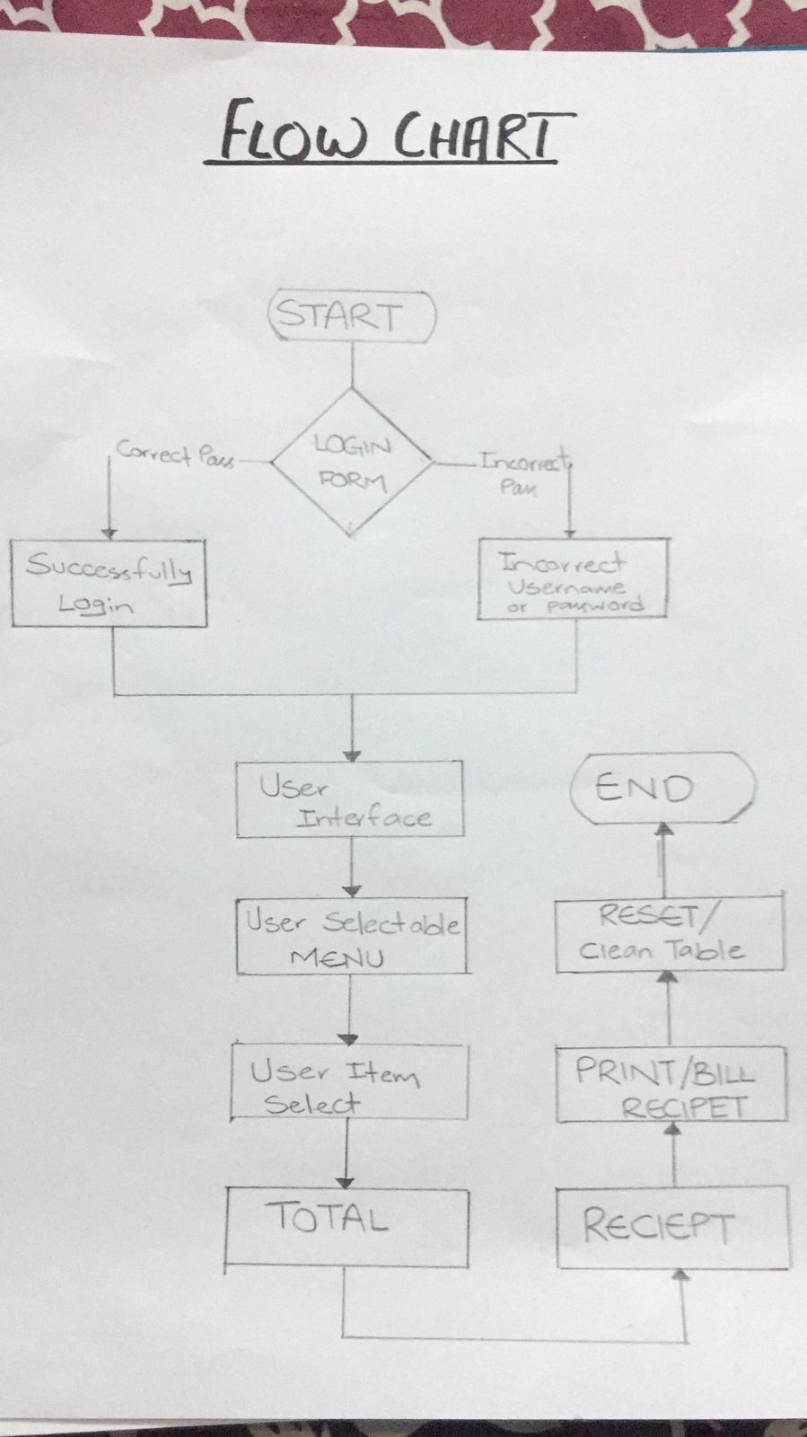

1. ***Activity Diagram for Login: optional***
2. ***Class Diagram for Login: optional***



1. ***State Chart Diagram for Login: optional***
   * 1. **Module 1 complete CRUD Creating bill and generating receipts**

1. ***Description:*** This function allows the user to Make a slip or generate bill for the customers. User will generate a slip for the customer and will give that bill after dine in.
2. ***Specification:***

|  |  |
| --- | --- |
| Description | makes a Bill / Slip |
| Inputs | From menu (items selected) |
| Source | 1. User inputs from Menu 2. Press Checkboxes … |
| Alternate Case | - |
| Outputs | Added |Viewed| Modified Bill /Slips |
| Destination | Computer screen  Image view box |
| Precondition | Valid information; user does not have another item or bill print at the same time |
| Post Condition | Bill generated for customer |
| Side Effects | - |

1. ***Use case Diagram:***



1. ***Flow of Event or Data Flow Diagram:***



1. ***Sequence Diagram:***

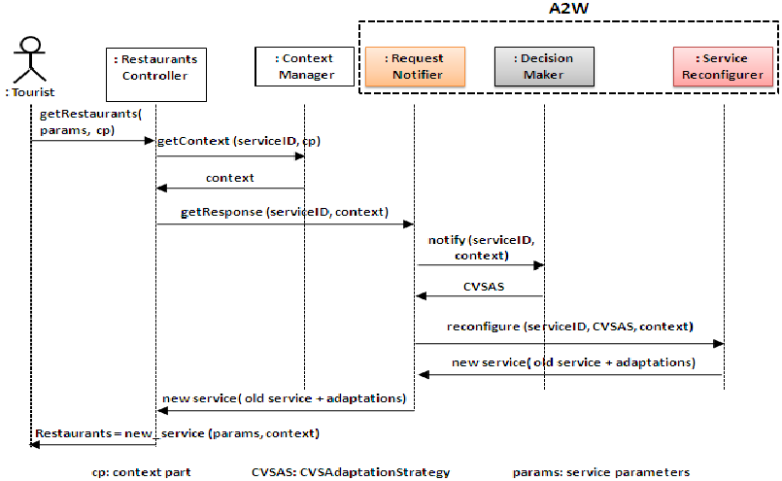

1. ***Activity Diagram:***
2. ***Class Diagram:***

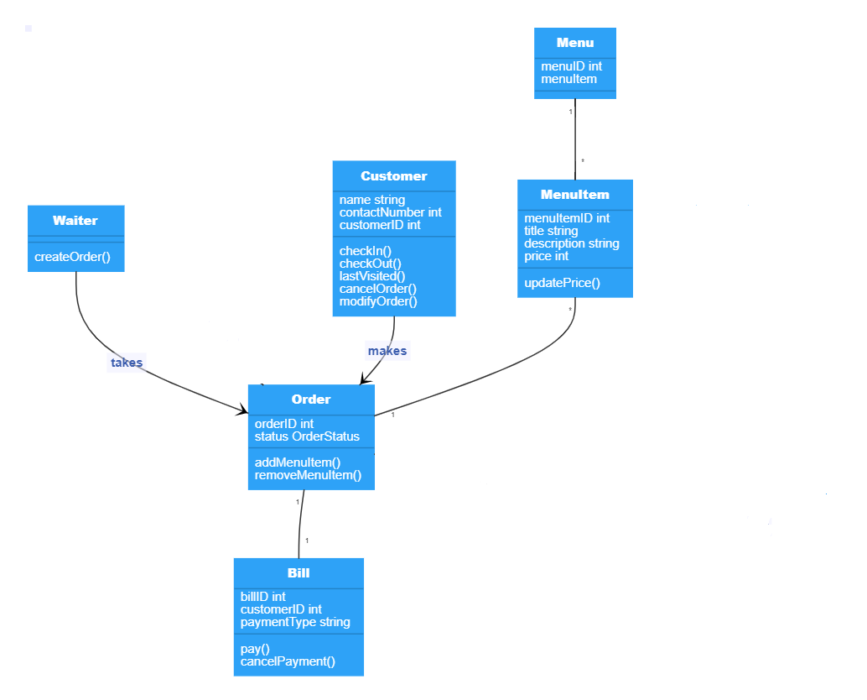

* + 1. **Module 3 complete CRUD can save all the records / bills as a backup**

***Description:*** This function will update all the information of the customer’s order and user can also print / save the bill or slip as a backup.

* + 1. **Module 4 complete CRUD user friendly interface / tick down menu**

***Description:*** This function allows the user to deal with a very easy interface in which he can select the items which customer have ordered and can generate slip of that order.

**3.2. External Interface Requirements**

**3.2.1 User Interfaces**

We will design that type of interface which will be easy in used and understandable for all type of user and layout will be simple and attractive for users. We will design ERD diagram of the database then normalized the following database and complete the normalization process and generate a database without issues. The diagrams and explanations below demonstrate the major transition from one user interface to another. This is a brief description. However, a more detailed demonstration is done in the prototype.



Selecting one of these functions will take the user to a different user interface. User have to enter the username and password then he can click on the Login button to go to the Menu Section.



Menu Section will be opened after the Login page. User has to select the given item. For Example if the customer wants a Burger. Than user will click on the checkbox of the Burger and can click tell them the amount.



 Then after selecting the Items which is mentioned in the Menu user will click on the Total button to add the item’s sum.



Now user will click on the Receipt button to see the Bill. In the Above diagram we can see that when the user clicked on the receipt button we can see the Bill in the image view box. User can also edit the items by clicking again on the menu checkbox, if he has done any mistake. User can also clear the complete interface by just clicking on the Reset button.



 Finally, the user can click on the save or print option which is given on the top header menu section. User can print the Bill or Slip just on one click, for the café’s backup.

**3.2.2 Hardware Interfaces**

The management system includes two major hardware components: Cell phone and regular PC's. The cell phones require WAP (wireless application protocol) network protocol, which is already programmed in the latest phones. And the Development PC for this management system will be PC with MS Windows 10.

**3.2.3 Software Interfaces**

An Oracle DBMS will be used to manage the database and any changes made to it. Furthermore the SQL will also be used for our database. Secondly, Visual Studio is the Compiler used for this Management system’s creation.

**3.3 Performance Requirements**

The following sections list the performance requirements for the system.

**3.3.1 User Requirements**

|  |  |
| --- | --- |
| User Requirements | **Description of Requirement For Design Environment** |
| Location(s) and Number(s) of Users | Local Areas |
| Expected Growth in Number of Users | TBD |
| After 1 Year | 50% |
| After 2 Years | TBD |
| After 3 Years | TBD |
| User Expectation |  |
| Interactivity | User expect that it provides a very easy to use graphical user interface |
| Reliability | For some applications, reliability must be 100% during the application session |
| Adaptability | Network must adapt to user additions, deletions and changes |
| Security | Encryption software would be used for Credit Card transactions |
| Cost / Funding | Less than PKR 250K |

**3.3.2 Application Requirements**

Since no specified service is indicated, then we have listed the applications as best – efforts. This may change as we learn more about the application.

The communication package is determined to be bursty in nature, with small data sizes and frequent transmissions. We can consider this application to be interactive-burst, while the database transaction-processing application is described by the café management as transferring large amounts of data (initial estimates are 1 MB/transaction), we have listed this application as interactive-bulk.

|  |  |  |
| --- | --- | --- |
| Categorizing  Applications | Best-Efforts | Application  Locations |
| Communication | 100 Kb/s | Local Areas |
| Database Access | 400 Kb/s | Local Areas |
| Database Transaction processing | 1.5 Mb/s | Local Areas |

**3.3.3 Host Requirements**

|  |  |  |
| --- | --- | --- |
|  | Type of Host or  Equipment | Numbers and  Locations |
| Host A | PC | Local Areas |
| Host B | Database Server | Karachi |
| Host C | Application Server | Karachi |

**3.4.1 Standards Compliance**

There are no design constraints that can be imposed by other standards limitations.

**3.4.2 Software Limitations**

* Must be run on a Core 2 Duo PC’s and Standard Smart Phone.
* Must have cell-phone web based capability to access the system from a mobile phone.

**3.4.3 Hardware Limitations**

* Input/output: One or two-button mouse, keyboard, cell-phone, or touch screen required.
* Network card required at thin-client terminals to make communication with server possible.

**3.5 Quality Characteristics**

There are a number of quality characteristics that apply to the Café Management System.

**3.5.1 Portability**

The cafe system will be developed using HTML and Java so that it can be accessed from any type of system using just a regular web browser. It will also be available to users that have web access on their cellular phones. The system will be tested on all types of hardware before being released to ensure that is it compliant with this requirement.

**3.5.2 Reliability**

All the performance of the project will be good because the response time of this project is well calculated users will see the result of their work at fast time there are no delays in project.

**3.5.3 Usability**

The project will be available 24 hours in a day without breakdown for user in case of any breakdown there will be a backup server which start works initially after the breakdown of main server. Maintenance of project will be made on monthly basis developer will check all the functions and data and if they find any data that will harm the software they will remove that.

**3.5.4 Correctness**

Only authorized person can access a particular module to run processes or store data. For example, the café owner can access related data and masters; he will not be authorized to access management level data. So that’s how it works.

**3.5.5 Flexibility**

This project will develop at that model that users will be never disappointed because it cover all the aspects which users wants from this project.

**3.5.6 Security**

Data of all users will be saved on centralized database server it will be private data of user so the access of this server will be only for those people who are from high level management.

**3.5.7 Maintainability**

Without fulfill the safety requirement running this project will be very dangerous for users, there are multiple safety requirements one of requirement is how to continuous run of app if a natural disaster effects a centralized database server for this we need a backup database server from another place.

**3.6 Other Requirements**

## The cafe management software should manage and store your day to day restaurants business. It should provide users access to relevant cafe information, and permit users to access the information within few mouse clicks. The software should be user-friendly and navigable. It should integrate all departments into a single frame to monitor closely each operation. Cafe management system software should offer other modules like Edit data or high level User Interface in the future.

**3.6.1 Data Base**

In this digital era, it is vital and requisite that every restaurant should have modern and reliable café management system, so that they can make better and faster decisions to maintain the growth of the alliance. But sometimes due to unawareness of the important features of cafe software, cafes might end up using software which fails to fulfill their needs. That’s why we decided to create cafe management software.

**3.6.3 Site Adaptation Requirements .**

There are no site adaptation requirements for this project.

**4. Supporting Information.**

There is no supporting information required for this project.